How to get these values in R.

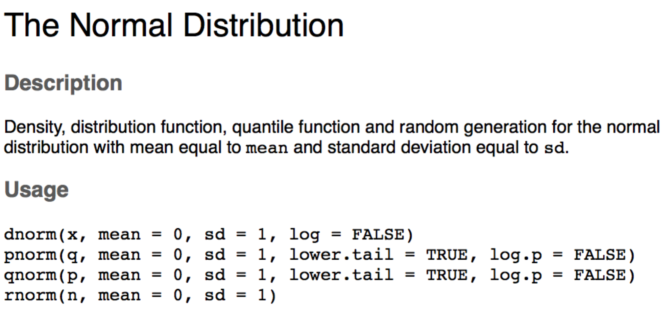

Which one should you use?

* P = probability distribution function
  + This function gives you the p-value associated with a specific Z, M/μ, σ combination.
  + You would use this function to determine if your *found* Z is significantly different from your *cut off* Z value.
    - You can just look at the Z values to tell if your found Z is more extreme than your cut off Z, but this test will tell you what the p value is for your Z score.
    - If your p value is less than your alpha (.01, .05, .10), then you would reject the null.
    - Both ways are correct! The bonus about p values is that they are always positive, because they are probabilities, which makes it a little easier on a test to determine what you should do.
  + q = Z, mean = M/μ, sd = σ
* Q = quantile distribution function
  + This function gives you the Z cut off for an associated p and M/μ, σ combination.
  + p = alpha/p value, null hypothesis mean = 0, sd = 1

Try:

